**Annual Report 2023-24**

**Youth Red Cross Society and Red Ribbon Club**

**3-Days Dental Health Check-up Camp**

3-days dental health checkup camp was organized in collaboration with the Department of Public Heath and Dentistry, Govt. Dental College and Research Institute, Sundra, Rajnandgaon was oragnised from 11/09/23 to 13/09/23. It was a lecture cum checkup camp. A large number of participants got benefitted from it. The specialty of it was that it was free for the outside people too and it was an attempt to give back to the society.

**State and National level marathon organized by NACO**

In order to raise awareness, NACO India had organized a state-level and a national-level marathon. The state-level marathon was organized at Raipur on 30 September 2023. Four students from our college had participated two in the male category and two in the female category in the 5 km marathon. Bhagvati Yadav stood first in the female category and was selected for National level marathon for 10 km at Goa from 6-8 October 2023. She participated and gave her best efforts.

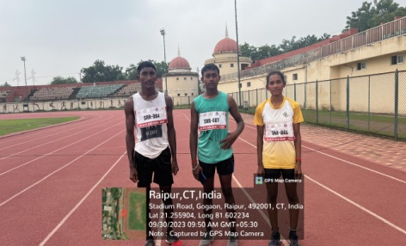

**15-Days AIDS Day celebration (1-15 December 2023)**

**Lecture on, “HIV/AIDS: - Causes and Prevention”**

**Resource person: - Dr. Esh Kumar Sahu**

A lecture on the causes and prevention of HIV/AIDS was organized by the Red Ribbon Club of the college on the occasion of World AIDS Day-2024 on 01/12 2023. Dr. Esh Kumar Sahu, Counselor, Civil Hospital, Khairagarh was the resource person who spoke beautifully and vividly about the causes and prevention of this incurable disease.

Dr. Sahu elaborately explained the four main causes of the HIV/AIDS disease that are, unsafe sex, through needles, from an infected mother to her baby and during organ transplants or blood transfusion. What made Dr. Sahu’s lecture more interesting that he discussed everything quoting case histories tat he had dealt with in his till medical career as a professional counselor.

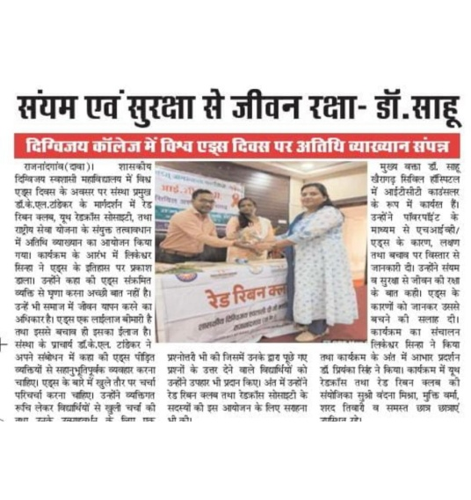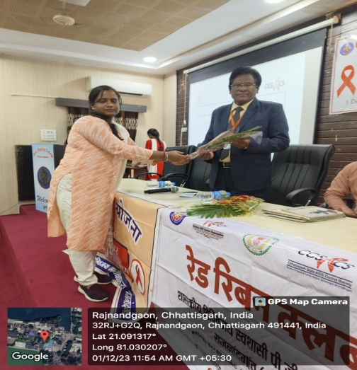

The program concluded with a brief questionnaire by Principal, Dr.K.L.Tandekar in which he asked the students questions and those giving answers were awarded on the spot with a notebook and a pen. The vote of thanks was presented by Dr. Priyanka Singh, Assistant Professor, Chemistry. The whole program was beautifully conducted by Mr. Likeshwar Sinha of the department of Chemistry. Prof. Vandana Mishra, coordinator, Red Ribbon Club and Youth Red Cross society were present along with Mr. Sharad Kumar Tiwari of Industrial Chemistry.

**Poster making competition on HIV/AIDS awareness revolving around the theme-Let communities lead**

A poster making competition was organized by the Red Ribbon Club of the college in collaboration with the Youth Red Cross society and the department of Zoology of the college. The central idea of the poster making competition was, “Let communities lead” which is also the theme of World AIDS day-2024. Students drew their creativities on paper with the help of vivid colors beautifully. Each of the posters drawn by the students spoke a different point of view on the theme. Every year, in order to raise awareness among the students, the Red Ribbon Club organizes various programs like this poster making competition which provides a canvas to the ideas of the students.

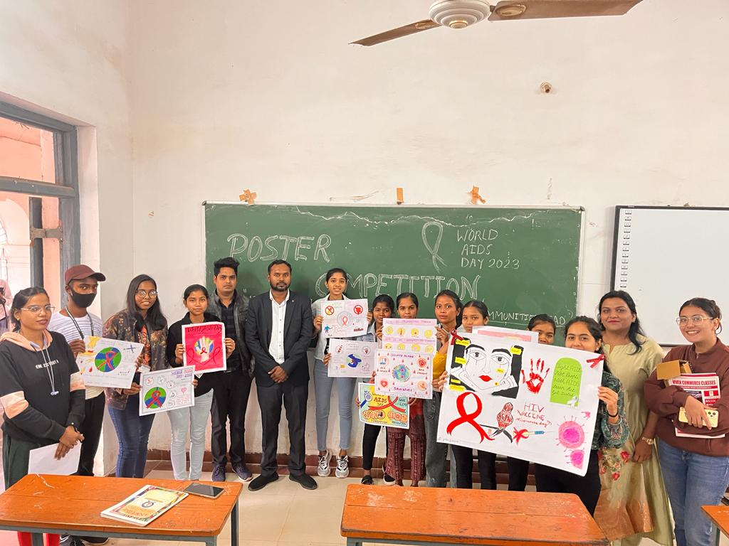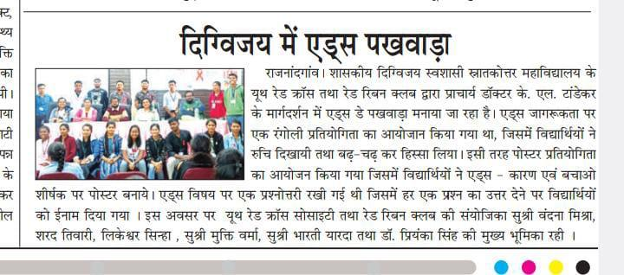

**Lecture cum demonstration on CPR by Dr. Kosma of the Govt. medical college, Pendri, Rajnandgaon and team**

A demo cum lecture was organized on 06/12/2023 was organized by the Youth Red Cross society and the Red Ribbon Club of the college in which a team of experts headed by Dr. Kosma from the Govt. Medical college, Pendri, Rajnandgaon demonstrated the whole process of CPR on human dummies of an infant, an adult human and a baby human dummy of 6-12 months. The team comprised of nearly 12 members in which each of the member was an expert of CPR on the patients of different age groups. After the demonstration, students and the faculty members were asked to perform the CPR on those human dummies.

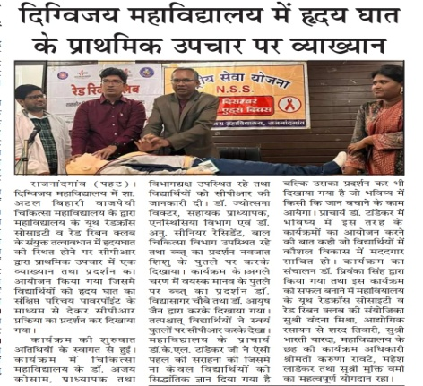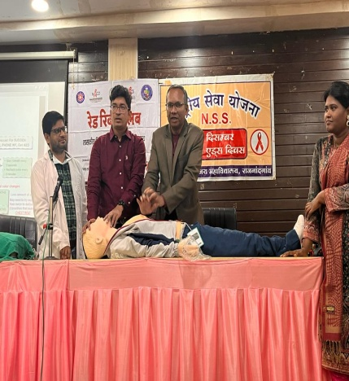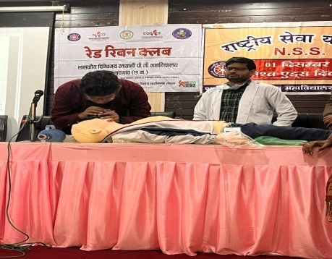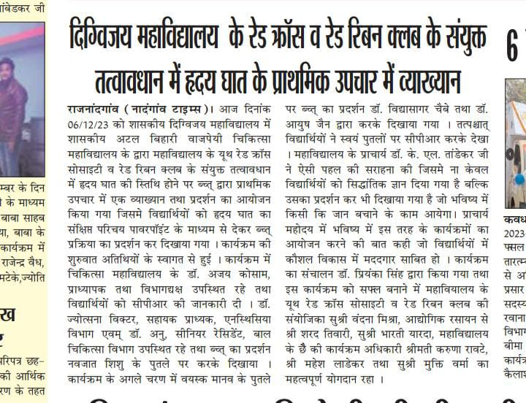

**A Free health check-up camp organized in collaboration with Shree Ram Multispecialty hospital**

A free health checkup camp was organized on 06/12/23 in collaboration with Shree Ram Multispecialty hospital, Raipur. A team from the hospital had setup an arrangement in which blood sugar, blood pressure and Hb count of the participants was tested for free.

**A lecture on acts and laws for people living with HIV/AIDS**

**Resource person: - Prof. Hemant Kumar Nandagauri**

The life of those living with HIV/AIDS is often very tough because they have to face discrimination due to their medical condition and in most of the cases it leads to depression and anxiety. Government has formulated many laws and acts in order to protect those people and to raise awareness about the same; we had organized a lecture on the same. The resource person was Mr. Hemant Kumar Nandagauri, Assistant Professor, Law, J.Yoganandam Chhattisgarh College, Raipur. He beautifully in an elaborative manner summed up various laws and acts that are made for people living with HIV/AIDS.